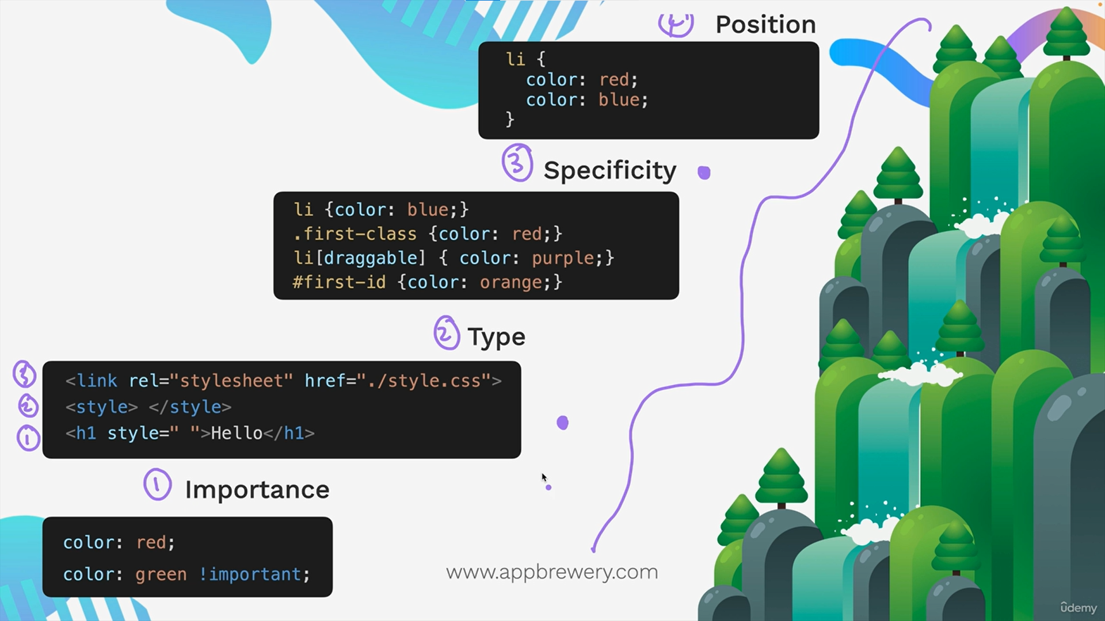

Top to bottom, in both cascade, and mini cascade

Type is more imp than specificity and such also holds 🡨------------- imp

Combining css selectors

1. Selector1 selector2 {  
   }

2 is a descendent of 1

1. Selector1 > selector2 {  
   }

2 is a child of 1 (only 1 generation gap)

1. Selector1, selector2 {  
   }

Apply to both 1 and 2

1. Selector1selector2 {  
   }

One that is both 1 and 2, li.class1#id1

We can also do

ul li.class1 {color:white}

decsendent of ul which are both li and have class class1

**Css positioning**

<https://appbrewery.github.io/css-positioning/>

goto this + always remember, relative is relative to its original position

static 🡪 default

reative 🡪 relative to default

absolute 🡪 relative to nearest positioned ancestor (top left corner if none)

fixed 🡪 relative to top left corner

display -----

<https://appbrewery.github.io/css-display/>

block 🡪 normal ones, takes full width

inline 🡪 takes only space needed, size cannot be changes, next element right to it if fpace available

inline-block 🡪 both changeable size and more than 1 element in 1 row

elememt vs tag -------------

<h1> is a tag

<h1> hi </h1> is an element

Float

Use it to wrap text around images  
-- previously ppl used this for basic layout like left side bar, and main text on right, but now we have better things for doing it.   
now only use it for wrap text around images.  
  
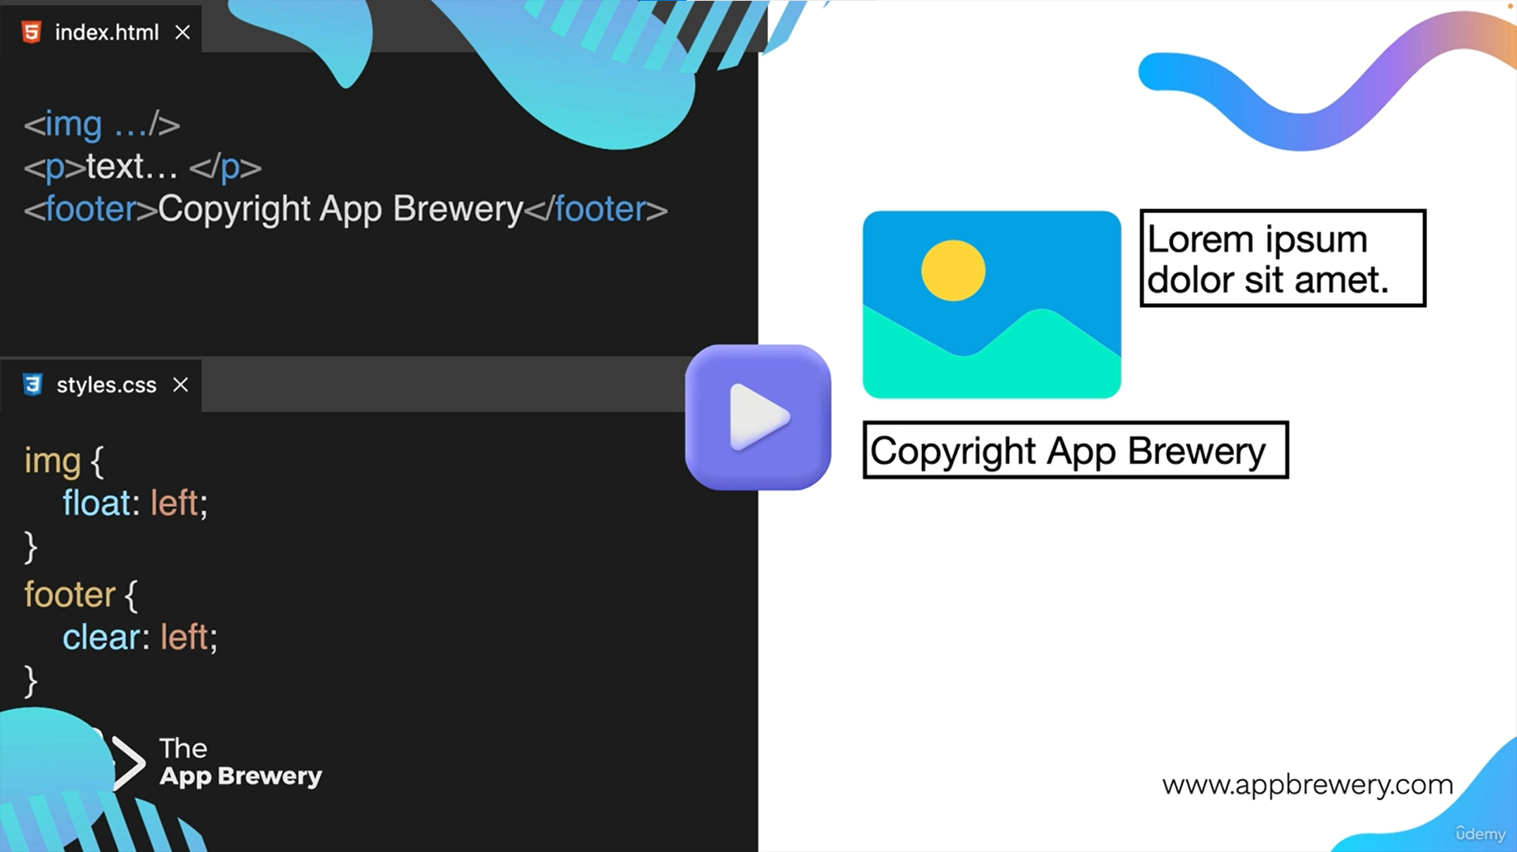

**4 way to create responsiveness**

1. Media

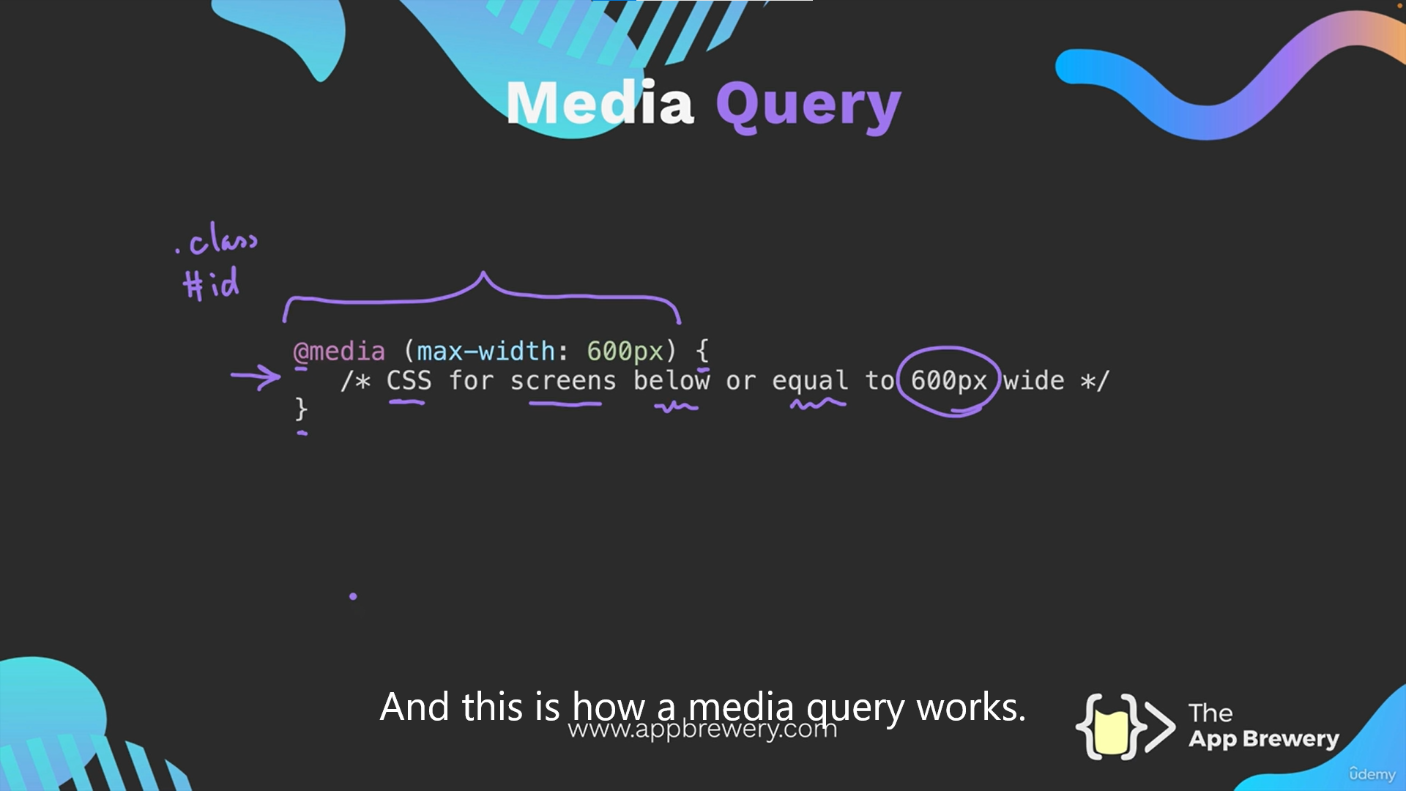

1. Grid, allows 2d   
   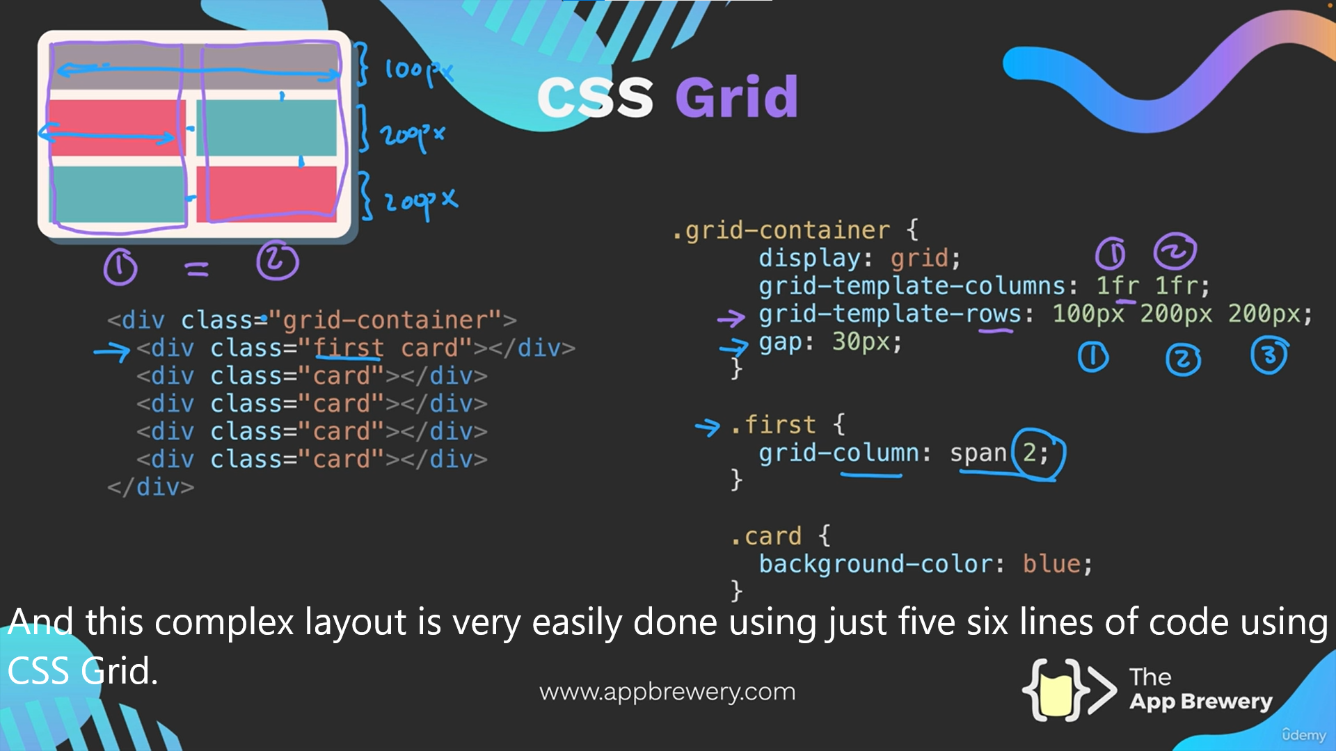
2. Flexbox (for 1d, either horizontal or vertical)

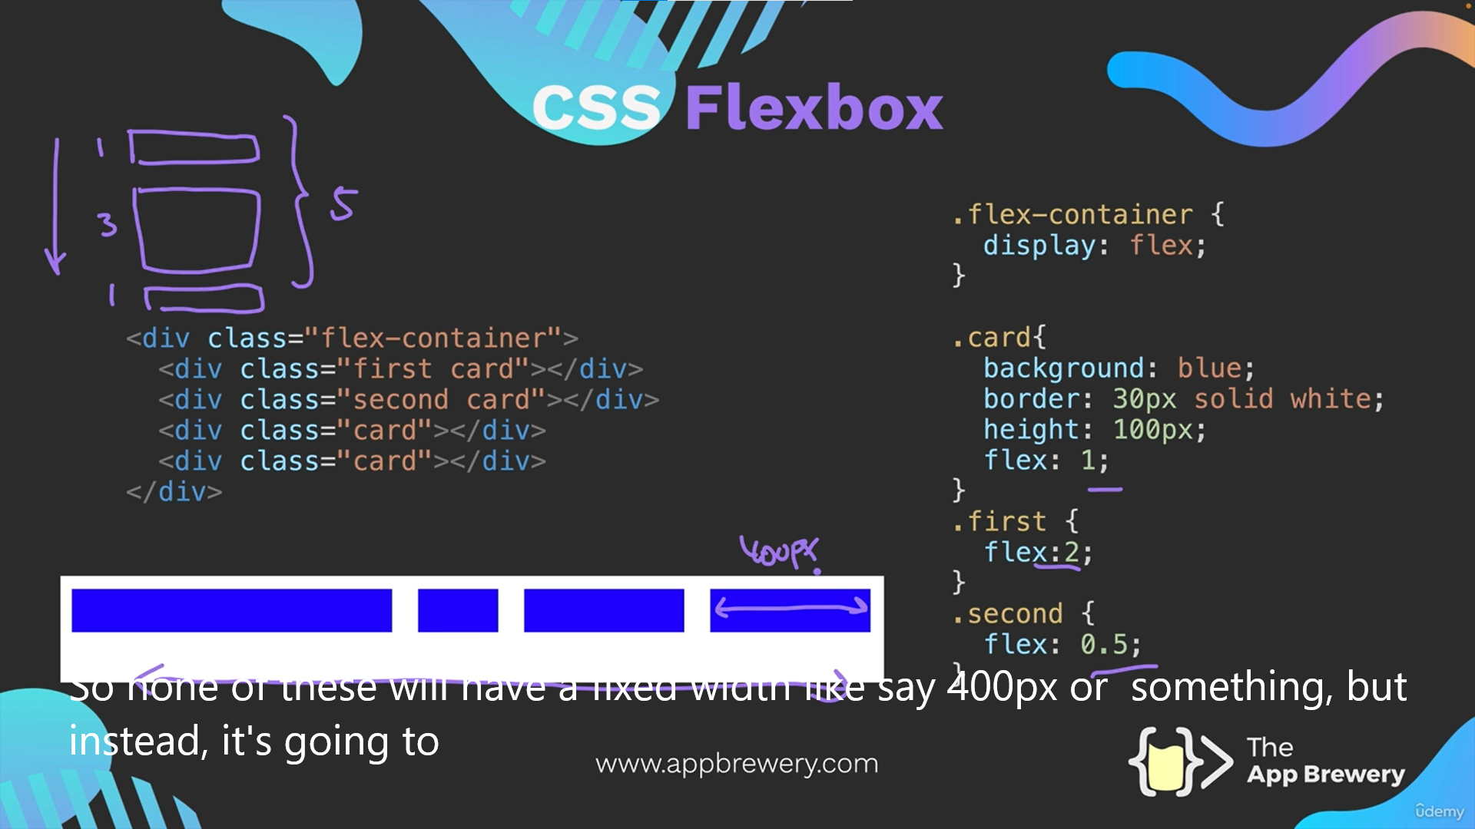

1. Bootstrap

